Appetizers
Name This Dip - $6.75 Balls on a Plate - $6.75
Grilled Sicilian Shrimp - $7.75 Pepperjack Cheese Sticks - $6.75
Tater Tots – Sm $3.75 lg $5.75 Seasoned Curly Fries – Sm $3.75 lg $5.75
Hawg “Riblet” Wings – $10.75 Brewster’s Chili – Sm $4.75 lg $6.75
“Our Famous”
Boneless Buffalo Wings – 5 for $6.75 10 for $9.75
Buffalo Chicken Wings – 5 for $6.75 10 for $9.75
Nachos
Brewster’s Nacho - $6.75 Mexi-Nacho – 9.75
Chicken Nacho - $9.75 Beef Nacho – 9.75
…add Veggies - $3.00
Salads
Garden Salad – $6.75 Caesar Salad - $6.75
Chef Salad - $10.75 Spinach Salad - $8.75
…add chicken or shrimp - $4.00
Burgers & Sandwiches
Build a Burger - $10.75 …. ½ pound of beef, you add the toppings!
Baja Chicken Sandwich - $8.75 Grilled Ham & Jack - $8.75
Buffalo Chicken Sub - $8.75 Rooster Meatball Sub - $10.75
The “Real Deal” Ribeye Steak Sandwich - $15.75
Brewster’s Club - $10.75 BLT - $8.75 ….add egg & cheese - $2.00

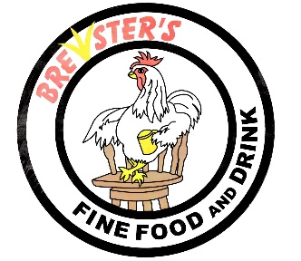
“Sumptin’ to Crow About”
Since 1997

For the safety of all of our customers and employees
Please, wear a face mask while entering/exiting or moving about
Be aware of social distancing, respect the space around you

